Software Requirements Specification (SRS)

Project Title
Smart Campus Navigation and Facility Locator System with Indoor Navigation, 3D Digital Twin and Visitor Management

1. Introduction

1.1 Purpose
The Smart Campus Navigation and Facility Locator System is a web-based application designed to simplify campus navigation for students, faculty, staff, and visitors. The system provides outdoor navigation using interactive maps and indoor navigation through 3D digital twin models of selected buildings (AS Block and IB Block). It also includes visitor management, facility location, emergency assistance, announcements, and voice-assisted navigation.
The objective is to reduce navigation difficulties within the campus while improving accessibility, visitor experience, and emergency response.

1.2 Scope
The system enables users to:
- Navigate outdoor campus roads and buildings.
- Search departments, classrooms, laboratories, offices, and facilities.
- View indoor 3D models of AS Block and IB Block.
- Find shortest walking paths.
- Register campus visitors.
- Track visitor approvals.
- Locate facilities like ATM, cafeteria, medical centre, washrooms, parking, auditorium, etc.
- Receive emergency alerts.
- Use voice commands for navigation.

1.3 Definitions
Term | Description
GIS | Geographic Information System
OSM | OpenStreetMap
Digital Twin | Interactive virtual representation of a building
Indoor Navigation | Navigation inside a building
Outdoor Navigation | Navigation across campus
Visitor | Person visiting campus
Faculty | Teaching staff
Admin | System administrator
JWT | JSON Web Token

1.4 Intended Audience
- Students
- Faculty
- Visitors
- Security Staff
- College Administration
- Developers
- Hackathon Judges

2. Overall Description

2.1 Product Perspective
The system consists of two navigation layers.

Outdoor Navigation
- Campus roads
- Building locations
- Parking
- Hostel
- Auditorium
- Sports Ground
- Cafeteria

Indoor Navigation
Implemented only for
- AS Block
- IB Block
The indoor model contains
- Classrooms
- Labs
- Lift
- Staircase
- Washrooms
- Faculty rooms
- Seminar halls

2.2 Product Functions

Authentication
- Student Login
- Faculty Login
- Visitor Login

Outdoor Navigation
- Interactive campus map
- Building search
- Facility search
- Route generation

Indoor Navigation
- Floor selection
- Room search
- 3D building view
- Walking directions
- Lift guidance
- Stair guidance

Visitor Management
- Visitor Registration
- Visitor Login
- Host Selection
- Visit Request
- Visit Approval
- Visit Rejection

Facility Locator
- ATM
- Cafeteria
- Medical Centre
- Parking
- Security Office
- Auditorium
- Hostels

Emergency Module
- SOS
- Emergency Contacts
- Nearby Medical Centre
- Security Office

Voice Navigation
Example
"Take me to AI Lab"
The system searches the destination and opens navigation automatically.

Announcements
- College circulars
- Events
- Notices

3. User Characteristics

Student
- Searches classrooms
- Finds laboratories
- Uses navigation

Faculty
- Receives visitor requests
- Navigates campus
- Views announcements

Visitor
- Registers visit
- Searches departments
- Navigates campus

Admin
- Adds buildings
- Adds rooms
- Approves visitors
- Updates announcements
- Manages users

4. Functional Requirements

Module 1 Authentication

FR-1
System shall allow Student Login.

FR-2
System shall allow Faculty Login.

FR-3
System shall allow Visitor Login.

FR-4
System shall authenticate using JWT.

Module 2 Outdoor Navigation

FR-5
Search buildings.

FR-6
Display shortest route.

FR-7
Display estimated walking time.

Module 3 Indoor Navigation

FR-8
Open 3D model.

FR-9
Display room locations.

FR-10
Display floor.

FR-11
Highlight destination.

FR-12
Display nearby washroom.

FR-13
Display lift.

FR-14
Display staircase.

Module 4 Visitor Management

FR-15
Visitor Registration.

FR-16
Visitor Login.

FR-17
Host Selection.

FR-18
Purpose Selection.

FR-19
Visit Approval.

FR-20
Visit Rejection.

Module 5 Facility Locator

FR-21
Search ATM.

FR-22
Search Cafeteria.

FR-23
Search Medical Centre.

FR-24
Search Parking.

FR-25
Search Auditorium.

Module 6 Notifications

FR-26
Emergency Alerts.

FR-27
Announcements.

FR-28
Visitor Status Notifications.

Module 7 Voice Navigation

FR-29
Accept voice input.

FR-30
Convert speech to text.

FR-31
Navigate to destination.

5. Non-Functional Requirements

Performance
- Response time less than 2 seconds
- 100+ concurrent users
- Route generation under 3 seconds

Security
- JWT Authentication
- bcrypt password hashing
- Role-based access
- HTTPS communication

Reliability
- 99% availability
- Automatic recovery after failures
- Reliable database transactions

Scalability
The system is designed to support future expansion without major architectural changes.
Future enhancements include:
- Additional academic blocks
- Indoor navigation for all buildings
- Mobile application
- Real-time classroom occupancy
- IoT sensor integration
- Smart parking
- AI chatbot

Maintainability
- Modular React components
- RESTful APIs
- Clean folder structure
- Separate frontend/backend

Availability
Available 24×7.

Usability
Simple interface.
Responsive design.
Minimal learning required.

Portability
Works on
- Chrome
- Edge
- Firefox
- Mobile browsers

6. System Architecture
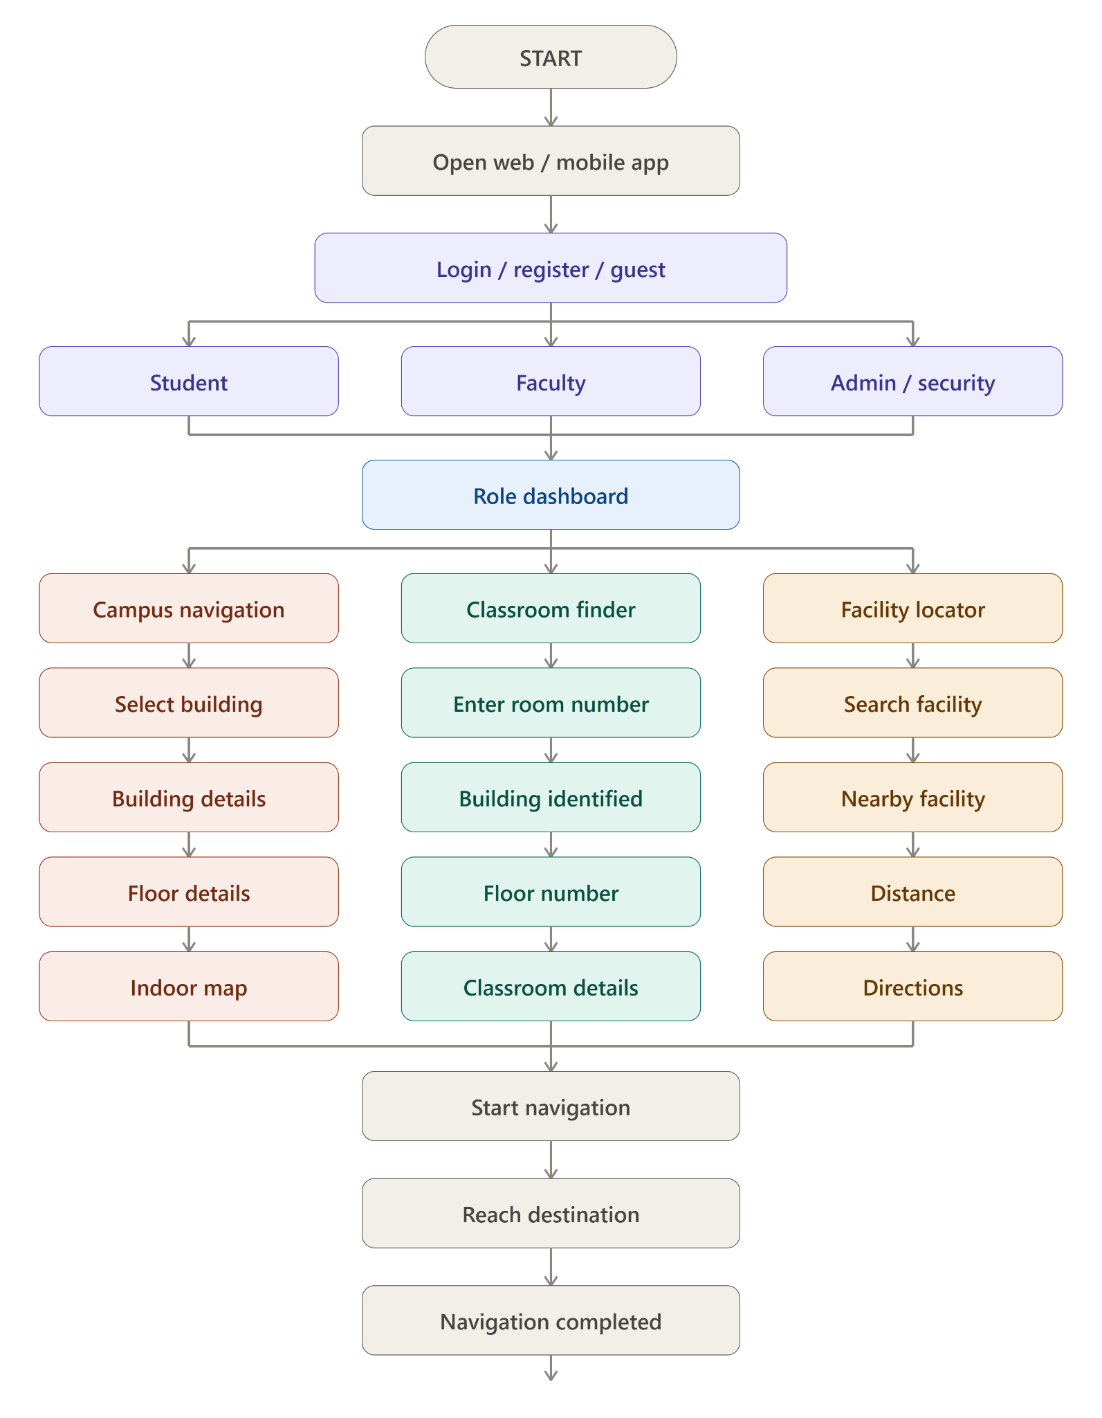

7. Database Design

Users
- UserID
- Name
- Email
- Password
- Role

Buildings
- BuildingID
- BuildingName
- Latitude
- Longitude

Floors
- FloorID
- BuildingID
- FloorNo

Rooms
- RoomID
- FloorID
- RoomNo
- RoomType

Facilities
- FacilityID
- FacilityName
- Building

Visitors
- VisitorID
- Name
- Host
- Purpose
- Status

Announcements
- AnnouncementID
- Title
- Description
- Date

8. Technology Stack
Technology | Purpose
React.js | Frontend
Tailwind CSS | UI
Node.js | Backend
Express.js | API
PostgreSQL | Database
Leaflet.js | Outdoor Map
OpenStreetMap | Map Data
Three.js | 3D Indoor Navigation
JWT | Authentication
bcrypt | Password Encryption
Socket.IO | Notifications
Web Speech API | Voice Navigation
GitHub | Version Control
Vercel | Frontend Deployment
Render | Backend Deployment

9. Assumptions
- Internet connection is available.
- Campus map coordinates are correct.
- Indoor models exist only for AS Block and IB Block.
- GPS accuracy is sufficient for outdoor navigation.

10. Constraints
- Indoor navigation is limited to AS and IB Blocks.
- GPS accuracy decreases indoors.
- Coohom models require internet access if used via shared links.
- Browser compatibility depends on WebGL support.

11. Future Enhancements
- Indoor navigation for every campus building.
- AR-based navigation.
- AI chatbot assistant.
- Smart parking availability.
- Classroom occupancy tracking.
- Attendance integration.
- Timetable integration.
- Real-time shuttle tracking.
- Emergency evacuation guidance.
- IoT-enabled smart campus features.

